12W 24,84 0,51

2

5

W

2

4

,

8

4

1

,

2

7

2

0

,

7

0

1

,

2

1

3

6

2

x

4

3

3

x

2

0

3

6

1

,

6

8

50W 24,84 2,55

7

5

W

2

4

,

8

4

3

,

8

0

2

0

,

7

0

3

,

6

2

6

7

9

x

4

3

3

x

2

0

3

6

5

,

2

100W 24,84 5,10

1

0

0

W

-

H

C

2

3

,

0

4

5

,

4

9

1

9

,

2

0

5

,

2

1

7

3

0

x

7

1

6

x

2

5

3

2

6

,

0

150W 24,84 7,64

205W 24,84 10,45

1

6

0

W

-

H

C

2

7

,

0

0

7

,

5

0

2

2

,

5

0

7

,

1

1

9

7

8

x

7

8

0

x

2

5

4

0

7

,

5

**SYSTEM CERTIFICATES**

IEC61215/IEC61730/IEC61701/IEC62716

ISO 9001: Qual ty Management System

ISO 14001: Env ronmental Management

ISO45001: Occupat onal Health and Safety

LEXRFOR A OLIVEABLNE WORLD

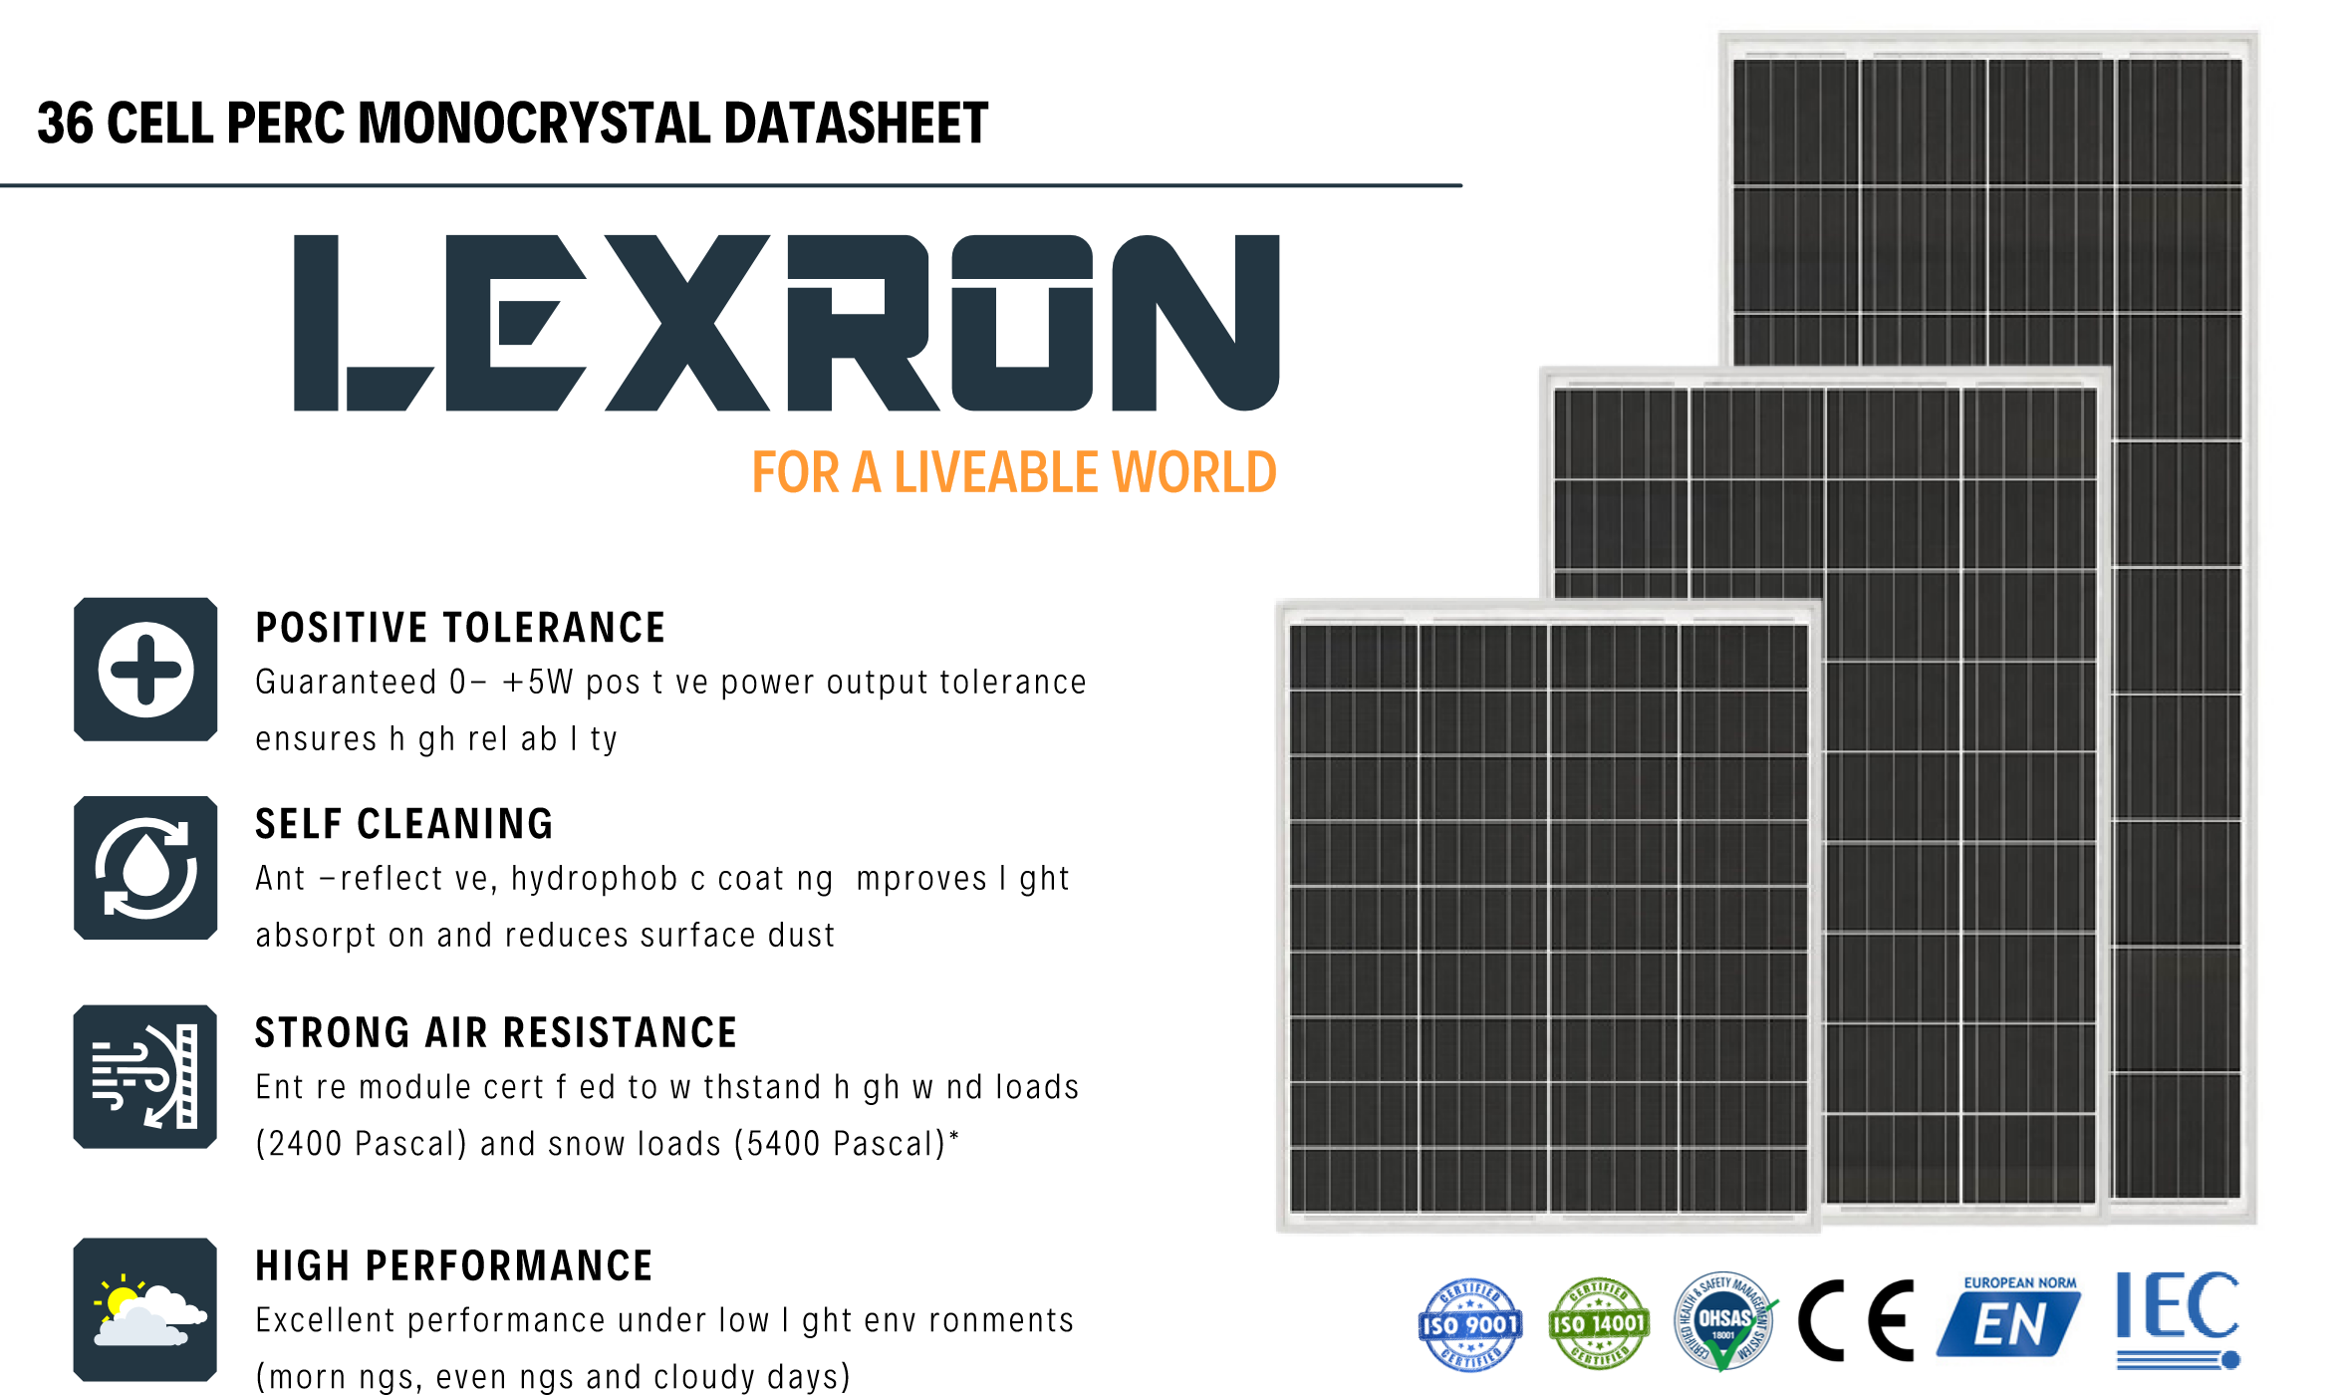20,70 0,58 255 x 355 x 20 36 1

P

E

A

K

P

O

W

E

R

O

P

E

N

C

I

R

C

U

I

T

V

O

L

T

A

G

E

V

o

c

(

V

)

S

H

O

R

T

C

I

R

C

U

I

T

V

O

L

T

A

G

E

I

s

c

(

A

)

P

E

A

K

P

O

W

E

R

V

m

p

(

V

)

P

E

A

K

C

U

R

R

E

N

T

I

M

P

(

A

)

S

I

Z

E

(

m

m

)

C

E

L

L

N

U

M

B

E

R

(

p

c

s

)

N

E

T

W

E

I

G

H

T

(

k

g

)

20,70 2,42 679 x 433 x 20 36 3,8

20,70 4,83 791 x 679 x 25 36 7

20,70 7,25 1148 x 679 x 25 36 9,5

20,70 9,90 1505 x 679 x 30 36 11,9

WARRANTY **Industry-lead ng warranty**

**%100 %97,5**

10 year Product Workmansh p Warranty

**Warranty**

25 year Power Warranty **%90**

2% f rst year degradat on

0.45% Annual Power Attenuat on **%80**

**10 Years 20 Years 25 Years**

LXR

ACS ENERJI

ITOB OSB Mah. Ekrem Dem rtas Cad. No: 44

Menderes - IZMIR

0232 799 00 98

www.acsenerj .com